Here are the steps to configure a CloudWatch log group after your **S3 File Gateway** is activated:

**Step 1: Open AWS Storage Gateway Console**

1. Sign in to the **AWS Management Console**.
2. Open the **Storage Gateway** service at  
    [AWS Storage Gateway Console](https://console.aws.amazon.com/storagegateway/home)

**Step 2: Select the Gateway**

1. In the left navigation pane, click on **Gateways**.
2. Choose the **S3 File Gateway** you want to configure.

**Step 3: Edit Gateway Information**

1. Click on **Actions** and select **Edit gateway information**.
2. Alternatively, go to the **Details** tab.
3. Under **Health logs**, if it shows **Not Enabled**, click **Configure log group**.

**Step 4: Choose a CloudWatch Log Group**

You have the following options:

* **Disable logging** – No logs will be sent to CloudWatch.
* **Create a new log group** – A new log group will be created for monitoring.
* **Use an existing log group** – Select an already existing CloudWatch log group.

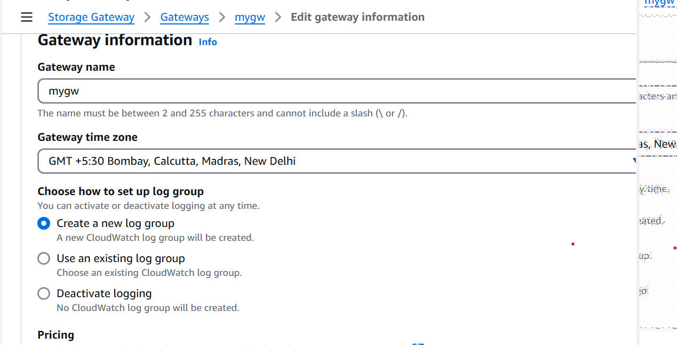

**Step 5: Save the Configuration**

1. If using an existing log group, select it from the **Existing log group list**.
2. Click **Save changes**.